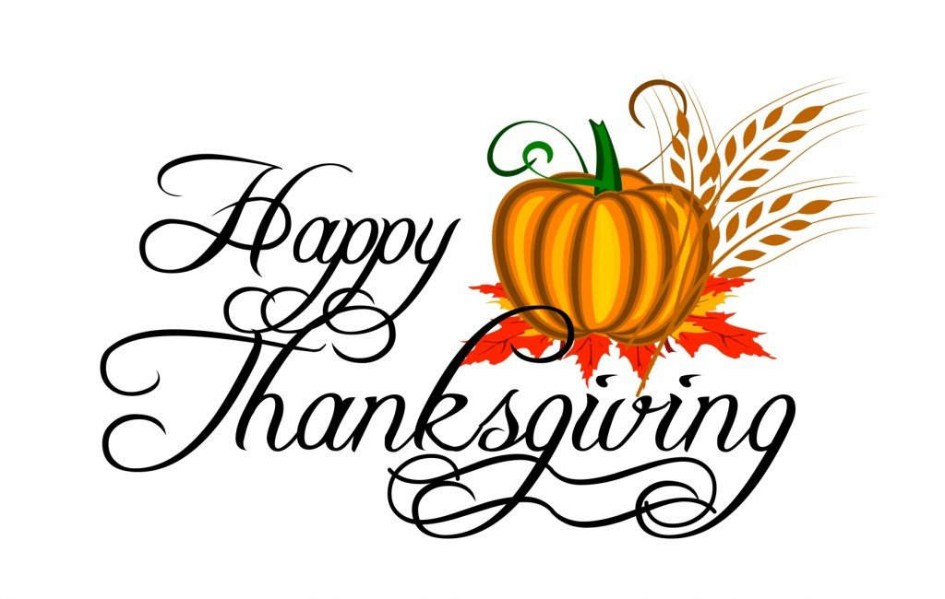
OOCS NOVEMBER 2026 LUNCH MENU
MONDAY | TUESDAY | WEDNESDAY | THURSDAY | FRIDAY
2  ALL SOULS  DAY  NO SCHOOL | 3  Corn Stew  Peas  Cornbread  Fruit/Milk | 4  Chicken Nuggets  Mixed Veggies  Fruit  Milk | 5  Macaroni  w/Meat sauce  Mixed Veggies  Tropical Fruit/Milk | 6  Hot Dogs  Baked Beans  Fruit  Milk
9  Chicken Stir Fry  Green Beans  Peaches  Milk | 10  Potatoes w/Hamburger  WW Tortilla/Corn  Fruit/Milk | 11  VETERANS  DAY  NO  SCHOOL | 12  Mac & Cheese  Peas  Fruit  Milk | 13  Corn Dogs  Cucumbers w/Ranch  Orange  Milk
16  Tostadas  w/Cheese  Green Beans  Fruit/Milk | 17  Lasagna  Green Beans  Breadsticks  Fruit/Milk | 18  Ham Salad  Crackers  Pears  Milk | 19 Thanksgiving Lunch  Turkey/Stuffing  Mashed Potatoe w/Gravy, Corn  Roll/Pie | 20  Beef Patty  Mashed Potatoes  w/Gravy/Peas  Applesauce/Milk
23  Chicken & Rice  Mixed Veggies  WW Tortilla  Peaches/Milk | 24  Bean Burritos  Corn  Fruit  Milk | 25  THANKSGIVING  BREAK  NO  SCHOOL | 26  THANKSGIVING  DAY  NO  SCHOOL | 27  THANKSGIVING  DAY  NO  SCHOOL
30  Frito Pies  Corn  Pears  Milk | Macaroni  w/Meat sauce  Mixed Veggies  Tropical Fruit/Milk

